Production Deployment Plan
L&G Meter Firmware S00237-06.02.R62

Document Control
CR / Project Number:
Version No: | 1.0
Created On: | 16/10/2025
Last Updated: | 25/11/2025
Status: | Final
Author/s: | Abel Lopez

Approval Status
Stakeholder Role | Stakeholder Name | Signature | Date
Network Intelligence Manager | Tobie DeVilliers | Tobie DeVilliers | 19/11/2025
Communications Manager | Stuart Bannister | Stuart Bannister | 19/11/2025
Meter Asset Manager | Goutham Lingam | Goutham Lingam | 12/11/2025
IOT System Service Lead | Wilton Gao | Wilton Gao | 12/11/2025
Market & Meter Data Manager Jac | Jack Friel | Jack Friel | 24/11/2025
Manager Communication Networks Quality | Leonard Jarillas

Document Purpose
The purpose of the Deployment Plan is to specify the business and technical resources, system requirements, steps and schedule for deployment. This document establishes the Go / No-Go criteria and the documentation requirements and gives the final approval to go ahead as planned.
Related Documents
This section will list related documents. Please note that if this document is updated these related documents may also need to be changed.
Document | Location | Relationship
L&G Meter Firmware S00237-06.02.R62 – Test Summary Report | Meter Firmware_TSR_R62_v1.0.docx | TSR

Reviewers
List the relevant reviewers who are responsible for the deliverables defined in this document.
Reviewer Title | Reviewer Name | Reviewed (Yes/No)
Metering Engineer • United Energy | Karl Ngo | Yes
Senior AMI Strategy Engineer • United Energy | Graeme Watson | Yes
Senior Metering Engineer United Energy | Fabian Perez | Yes
AMI Communications Control Operator Network | Percy Arachchige | Yes
Communication Networks Laboratory Technician • Network | Kamau Njuguna | No
Smart Grid Testing SME Network | Manoj Karla | Yes
AMI Communications Analyst • United Energy | Jogy Cherian | No
Asset Engineer (Distribution Intelligence) Network | Hansi Rajapaksha Vithanage Dona | Yes
UIQ System Analyst Information Technology | Nelson Manio | No
Compliance & Projects Analyst | Wayne Johnson | Yes
IoT Systems Administrator United Energy | Amy Fan | Yes
Market & Meter Data Team Leader United Energy | Can Turk | Yes

Document Distribution (Information only)
Distributed to

Table of Contents
1. Introduction 4
1.1. Project Background 4
1.2. Objectives 4
1.3. Dependencies 4
2. Deployment Approach 5
2.1. Scope 5
2.2. Deployment Schedule and Stages 6
2.2.1. Deployment Schedule 6
2.2.2. Deployment Stages 7
1. Pre-analysis Stage 8
2. BVT Stage (50 Meters) 9
3. Stage 1 (100 Meters) 10
4. Stage 2 (500 meters) 12
5. Stage 3 (All meters) 13
6. BAU Stage (All remaining Meters) 15
3. Deployment Roles and Responsibilities 17
3.1. Deployment Lead 17
3.2. Go – No Go 17
3.3. Escalation 17
3.4. Stakeholder Communication 17
3.5. Operational and Support Groups 17
4. Identified Risks 19
5. Appendix 20
5.1. FWU Progress Report 20
6. Revision 21

Introduction

Project Background
There is a new meter firmware 06.02.R62 released from L&G for U1200, U3300, and U3350 meters. This FW provides the fix for some of the existing meter FW defects. This firmware will be used to upgrade the production meters.

Before deploying said Meter firmware to the production AMI system, it is essential to ensure that the new release poses minimal risk to business operations and meets all relevant requirements. To this end, the Communication Networks Quality Group has conducted rigorous testing to verify the firmware's functionality and performance. This document will provide a synopsis of the firmware covered and details of the results.

Objectives
- Upgrade all L+G U1200, U3300, and U3350 meter firmware to Meter FW R62 based on the TSR.
- These are applicable for both UE and VPN meters as UE and VPN have the same meter type, meter firmware, NIC firmware and UIQ versions.

Dependencies
- L&G Meter Firmware S00237-06.02.R62 – Test Summary Report

Deployment Approach

Scope
- Both UE and VPN AMI network and devices are in scope.
- Meters with the following properties will be in scope of this deployment activity.
Meter Type | Short Description | Meter Firmware | NIC Variant | NIC Firmware
10MLx | L+G IEC U1200 1PH 1E HAN | 5.5.R50 | ARM/AKIO | 5.4.13/5.4.33
11MLx | L+G IEC U1200 1PH 1E LC HAN | 5.5.R50 | ARM/AKIO | 5.4.13/5.4.33
12MLx | L+G IEC U1200 1PH 2E LC HAN | 5.5.R50 | ARM/AKIO | 5.4.13/5.4.33
30MLx | L+G IEC U3300 3PH DIR CONN HAN | 5.5.R50 | ARM/AKIO | 5.4.13/5.4.33
31MLx | L+G IEC U3300 3PH DIR CONN LC HAN | 5.5.R50 | ARM/AKIO | 5.4.13/5.4.33
C0MLx | L+G IEC U3350 3PH CT CONN LC | 5.5.R50 | AKIO | 5.4.33
Table 1: Meter Firmware in Scope
- Please find below list of each meter count based on Meter Type:
Meter Type | Short Description | Meter Firmware | Current Meter Firmware | Count of Meters
10MLx | L+G IEC U1200 1PH 1E HAN | 06.02.R62 | 5.5.R50 | 501,914
11MLx | L+G IEC U1200 1PH 1E LC HAN | 06.02.R62 | 5.5.R50 | 40,116
12MLx | L+G IEC U1200 1PH 2E LC HAN | 06.02.R62 | 5.5.R50 | 181,612
30MLx | L+G IEC U3300 3PH DIR CONN HAN | 06.02.R62 | 5.5.R50 | 123,547
31MLx | L+G IEC U3300 3PH DIR CONN LC HAN | 06.02.R62 | 5.5.R50 | 11,355
C0MLx | L+G IEC U3350 3PH CT CONN LC | 06.02.R62 | 5.5.R50 | 7204
Table 2: VPN Meters in Scope

Meter Type | Short Description | Meter Firmware | Current Meter Firmware | Count of Meters
CAT1 | L+G IEC U1200 1PH 1E HAN | 06.02.R62 | 0 | 0
CAT2 | L+G IEC U1200 1PH 1E LC HAN | 06.02.R62 | 0 | 0
CAT3 | L+G IEC U1200 1PH 2E LC HAN | 06.02.R62 | 0 | 0
CAT4 | L+G IEC U3300 3PH DIR CONN HAN | 06.02.R62 | 0 | 0
CAT5 | L+G IEC U3300 3PH DIR CONN LC HAN | 06.02.R62 | 0 | 0
CAT6 | L+G IEC U3350 3PH CT CONN LC | 06.02.R62 | 5.5.R50 | 534
Table 3: UE Meters in Scope

Deployment Schedule and Stages
The upgrade shall be divided into several stages as shown in the figure below.
Note: The mentioned deployment schedule for different stages will be followed for each of the meter type: 10ML,11ML,12ML,30ML,31ML,C0ML for the Meter Firmware separately.
    - Deployment Schedule
The proposed deployment schedule is shown in the figure below in reference to the start date of 3RD of November 2025. This start date is dependent on the approval of the deployment plan (this document) and will be revised accordingly. The duration are estimates based on previous firmware upgrades and will be monitored and adjusted during the deployment activity.
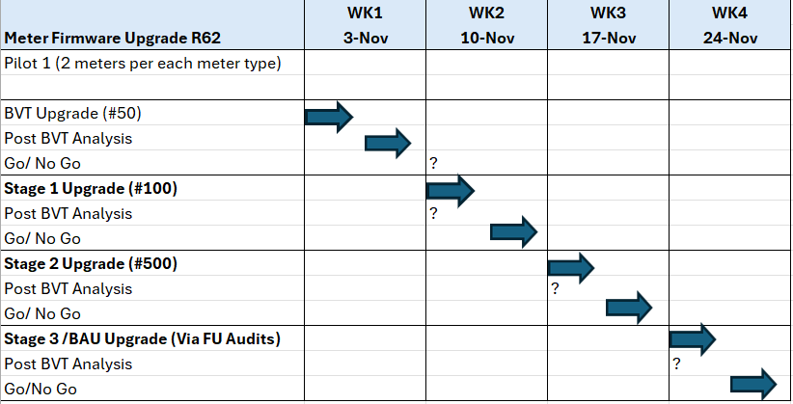
Figure 1- Deployment Schedule

    - Deployment Stages
The BVT upgrade of the meters should be carried out in well-established areas, preferably in proximity to the Burnley Depot or Brooklyn Depot.
Example: Sunshine City
The upgrade shall be divided into several stages as shown in the figure below :

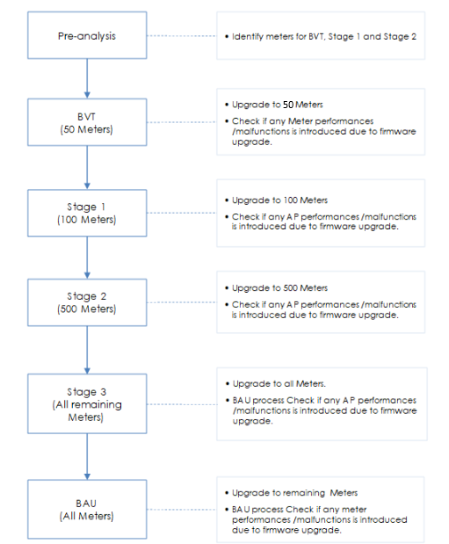
Figure 2 - Firmware deployment stages

Progress of the firmware upgrade shall be monitored through the FWU reporting tool and FWU project details.

Pre-analysis Stage

Resources Required: ACCG

The pre-analysis stage shall be composed of the following activities:
- Identify Meters with operational state “Active” and Disconnected” having good communication history and avoid using COMMS_FLAPPERS
- List all meters that are to be in scope of BVT, Stage 1 and Stage 2 based on the following criteria:
  - Operation state : Active
  - Location : Close proximity to Burnley depot or Brooklyn depot
  - BVT Stage : 50 Meters (U1200/U3300/U3350) Meter FW 5.5.R48/R50
  - Stage 1: 100 Meters (U1200/U3300/U3350) Meter FW 5.5.R48/R50
  - Stage 2: 500 Meters (U1200/U3300/U3350) Meter FW 5.5.R48/R50
- Import list of meters BVT,Stage 1 and Stage 2 into the tracking spreadsheet located in:
  - EN/SD Hub - Communication Networks Quality - 2025 - L&G 06.02.R62 Firmware - All Documents
- Upgrade initially for only 1 meter per Meter Type:
  - L+G IEC U1200 1PH 1E HAN
  - L+G IEC U1200 1PH 1E LC HAN
  - L+G IEC U1200 1PH 2E LC HAN
  - L+G IEC U3300 3PH DIR CONN HAN
  - L+G IEC U3300 3PH DIR CONN LC HAN
  - L+G IEC U3350 3PH CT CONN LC
- Collect all pre upgrade data and record in the tracking spreadsheet. The pre and post firmware upgrade data shall be compared to ensure that the expected behaviour is observed.

Data to be collected | Method | Expected
Meter communication | UIQ Ping Schedule/NC/MKT | Meters have >99% comms performance
Meter Interval data Read | UIQ Schedule/NC | Meter data up to date available
Meter events | UIQ Schedule | There are no unexpected meter events generated
Meter Performance | UIQ Schedule | Hourly meter read performance as expected
Table 4 - Pre & Post Upgrade Data

BVT Stage (50 Meters)

Resources Required: ACCG, UIQ Support, Data Analytics, AMI Data (MDP)

During the BVT stage, a small number (50) of meters shall be upgraded and the impact of the upgrade analysed. This minimises the risk of meter malfunctions, if any, that may be introduced by the new firmware that has not been detected during testing.

Steps:
  - Create and run the FWU project for each meter type using the appropriate firmware image type. The upgrade setting for each FWU upgrade shall be as follows:
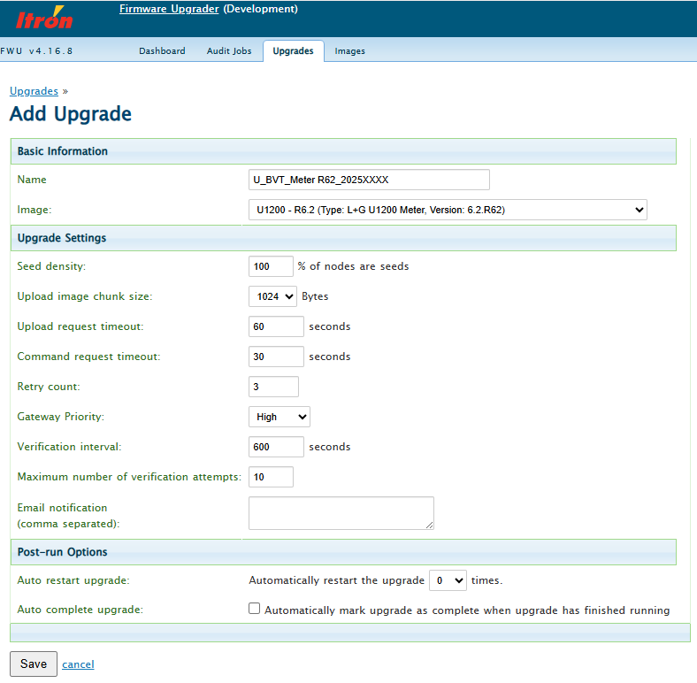

  - Monitor the success rate and duration of each firmware upgrade. Report any noticeable slowness in the upgrade compared to past meter firmware upgrades.
  - Collect all post upgrade data and record in the tracking spreadsheet.
  - Compare the pre and post upgrade data in the tracking spreadsheet and verify the impact of the deployment of new firmware to the Meter performance.
  - Check for any communications from UIQ Support, Data Analytics and AMI Data team for any major impact. If any major adverse effect is detected in this stage, stop the deployment and escalate to the Communication Networks Quality Manager. The issue will be investigated further with assistance from the following teams:
- Communication Networks Quality
- Other teams as needed
  - If all issues, if any, has been resolved, proceed to the next stage.
  - Communicate results of the BVT, and if proceeding to the next stage, to the relevant stakeholders.

Stage 1 (100 Meters)

Resources Required: ACCG, UIQ Support or Data Analytics

In Stage 1, a larger number (100) of meters shall be upgraded and the impact of the upgrade analysed.

Steps:
- Create and run the FWU project for each firmware image type. The upgrade setting for each FWU upgrade shall be as follows:
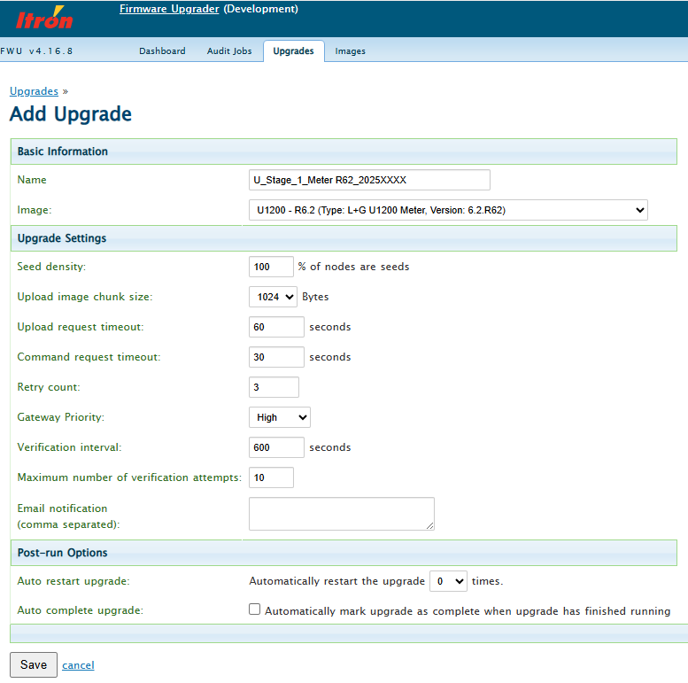
- Monitor the success rate and duration of each firmware upgrade. Report any noticeable slowness in the upgrade compared to past meter firmware upgrades.
- Monitor for any meter failed the upgrade and send a list to the Communication Networks Quality Manager for investigation and triage.
- Collect all post upgrade data and record in the tracking spreadsheet.
- Compare the pre and post upgrade data in the tracking spreadsheet and verify the impact of the deployment of new firmware to the Meter performance.
- Check for any communications from UIQ Support, Data Analytics and AMI Data team for any major impact. If any major effect is detected in this stage, stop the deployment and escalate to the Communication Networks Quality Manager. The issue will be investigated further with assistance from the following teams:
- Communication Networks Quality
- Other teams as needed
- If all issues, if any, has been resolved, proceed to the next stage.
- Communicate results of the Stage 1, and if proceeding to the next stage, to the relevant stakeholders.

Stage 2 (500 meters)

Resources Required: ACCG, UIQ Support or Data Analytics

In Stage 2, a significant number (500) of meters shall be upgraded and the impact of the upgrade analysed.

Steps:
- Create and run the FWU project for each firmware image type. The upgrade setting for each FWU upgrade shall be as follows:
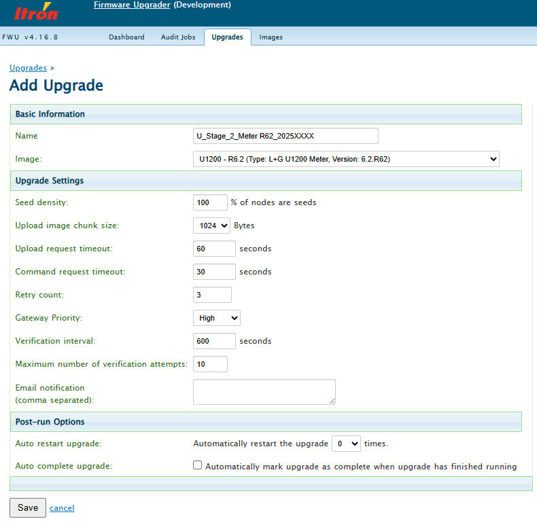

- Monitor the success rate and duration of each firmware upgrade. Report any noticeable slowness in the upgrade compared to past meter firmware upgrades. If necessary, restart the FWU project.
- Monitor for any meter that failed the upgrade and send a list to the Communication Networks Quality Manager for investigation and triage.
- Collect all post upgrade data and record in the tracking spreadsheet.
- Check for any communications from UIQ Support, Data Analytics and AMI Data team for any major impact. If any major effect is detected in this stage, stop the deployment and escalate to the Communication Networks Quality Manager. The issue will be investigated further with assistance from the following teams:
- Communication Networks Quality
- Other teams as needed
- If all issues, if any, has been resolved, proceed to the next stage.
- Communicate results of Stage 2, and if proceeding to the next stage, to the relevant stakeholders.

Stage 3 (All meters)

Resources Required: ACCG, UIQ Support or Data Analytics

In Stage 3, there is now high confidence that the new firmware does not pose any significant risk to the meter functionality. All the remaining meters that need to be upgraded to the new firmware will be covered in this stage.

Steps:
- Create and run the FWU project for each firmware image type. The upgrade setting for each FWU upgrade shall be as follows:
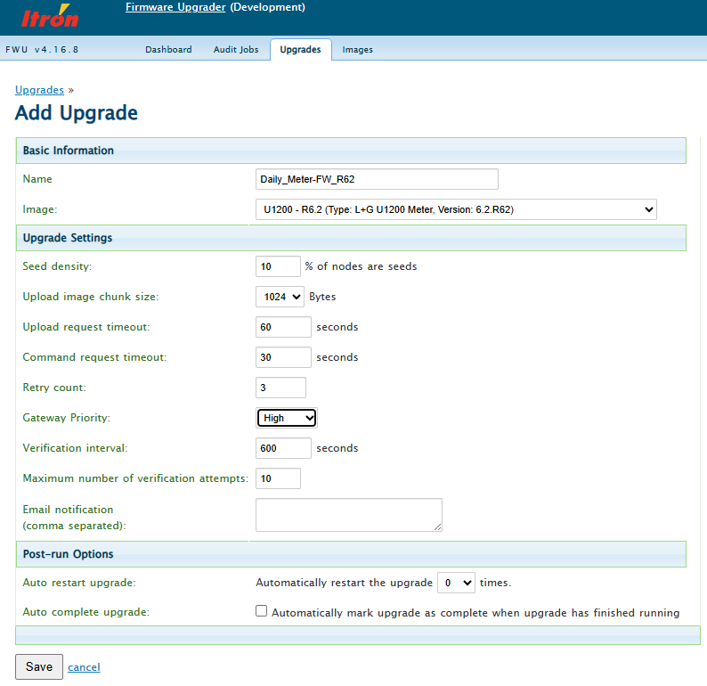
- Monitor the success rate and duration of each firmware upgrade. Report any noticeable slowness in the upgrade compared to past meter firmware upgrades. If necessary, restart the FWU project.
- Monitor for meters that failed the upgrade and send a list to the Communication Networks Quality Manager for investigation and triage.
- Collect all post upgrade data and record in the tracking spreadsheet.
- Compare the pre and post upgrade data in the tracking spreadsheet and verify the impact of the deployment of new firmware to the meter performance.
- Check for any communications from UIQ Support, Data Analytics and AMI Data team for any major impact. If any major effect is detected in this stage, stop the deployment and escalate to the Communication Networks Quality Manager. The issue will be investigated further with assistance from the following teams:
- Communication Networks Quality
- Other teams as needed
- If all issues, if any, has been resolved, proceed to the next stage.
- Communicate results of Stage 3, and if proceeding to the next stage, to the relevant stakeholders.

BAU Stage (All remaining Meters)

Resources Required: ACCG, UIQ Support or Data Analytics

In the BAU stage, all the remaining meters shall be targeted and upgraded to the New firmware.

Steps:
- Create the FWU audit for each NIC Architecture type. The suggested audit setting for each FWU audit shall be as follows:
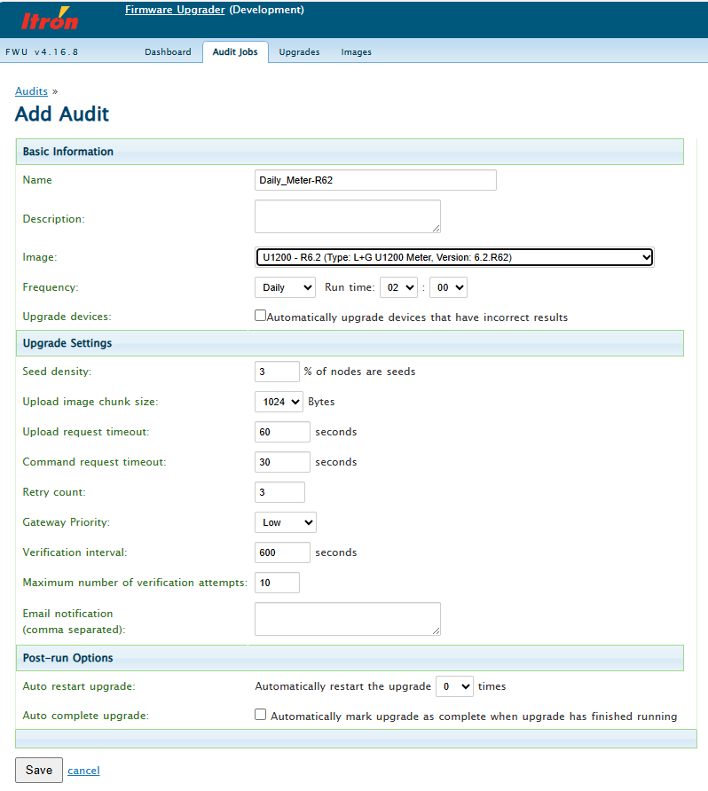
- Notify relevant stakeholders prior to commencement of the audit and automatic upgrade. UIQ Support team will need to monitor the backend system and UIQ application during the upgrade.
- Monitor the success rate and duration of each automatic firmware upgrade daily. Report any noticeable slowness in the upgrade compared to past meter firmware upgrades. If necessary, restart the FWU project.
- Continue to monitor the events and look for any critical events, not limited to those listed below.
- Check for any communications from UIQ Support, Data Analytics and AMI Data team for any major impact. If any major effect is detected in this stage, stop the deployment and escalate to the Communication Networks Quality Manager. The issue will be investigated further with assistance from the following teams:
- Communication Networks Quality
- Other teams as needed
- Continue to monitor the upgrade success rate, critical events.
- Communicate firmware upgrade progress and any issues to relevant stakeholders.

Deployment Roles and Responsibilities

Deployment Lead
The deployment leads for the new Meter firmware are:
- VPN/UE: Percy Arachchige/Abel Lopez

Go – No Go
Each stage will have a go-no go checkpoint with the following stakeholders as approvers:

Deployment Stage | Role | Stakeholder
Stage 1  Stage 2 | Metering Engineer • United Energy | Karl Ngo
 | Senior AMI Strategy Engineer • United Energy | Graeme Watson
 | AMI Communications Analyst • Network | Sangsukdee, Wayne
 | Communication Networks Laboratory Techni • Network | Njuguna, Kamau
 | AMI Communications Analyst • United Energy | Cherian, Jogy
Stage 3
BAU Upgrade
 | Communications Manager | Stuart Bannister
 | Meter Asset Manager | Goutham Lingam
 | IOT System Service Lead | Wilton Gao
 | Market & Meter Data Manager Jac | Jack Friel
 | Manager Communication Networks Quality | Leonard Jarillas

Escalation
The first point of escalation will be the Communication Networks Quality Manager and depending on the issue, he/she will contact the relevant stakeholders in the reviewer’s list.

Stakeholder Communication
The stakeholders in the reviewer and approver list shall be notified of the progress and any issue found during the firmware upgrade deployment. The mode of communication shall be via email.

Operational and Support Groups
- List the support to be provided for the deployment and post go live. For example, what role is the service desk playing and have they been informed. Will the Business team provide trained floor walkers on go live day?
- ACCG
  - Overall firmware upgrade process
  - Send progress report
- UIQ Support
  - General UIQ application support and monitoring
  - Support on data requests that can’t be easily retrieve from the UI
- Data Analytics
  - SIQ and PQ polling data monitoring
  - Support on data requests that can’t be easily retrieve from the UI
- AMI Data (MDP)
  - AMI data to market monitoring
Complete the table below, listing all required resources for the deployment.

Identified Risks

Ref | Description | Details | Mitigation
Risk#1 | Undesired meter functionality due to new Meter firmware | Meter stops functioning correctly resulting loss of functionality | - Critical tests have been done during testing.  - Staged the deployment of the Meter firmware.  - Revert the firmware to the previous version
Risk#2 | If the meters are Auto Disconnected due to load exceeding the set limit, it may happen that the alarms are missed on UIQ. | Only the alarms missed on UIQ. | - The meter can be analysed using the events stored in the meter.  - There will be corresponding Auto Disconnection event stored in the meters.

Appendix
Include exports from ALM for the execution results and defects.

FWU Progress Report
The following information shall be sent as part of the daily FWU progress report.

Issue# | Summary | Status

Project Name | Start | Stop | Total Devices | Succeeded | Failed | % completed

Revision
Version | Date | Updated by | Comments
0.1 | 16/10/2025 | AL | Draft
1.0 | 25/11/2025 | AL | Final

